KRISHI SETU

in partial fulfillment of the requirements for the award of the degree of Bachelor of Technology in

COMPUTER SCIENCE AND BUSINESS SYSTEMS

Submitted by

NAME OF THE CANDIDATE(S)

Sudeep Kuralkar
Himanshu Sherje
Under the guidance of

Prof. Renuka Raut
Assistant Professor

Academic Year 2025-26

Department of Computer Science and Business Systems



ST. VINCENT PALLOTTI COLLEGE OF ENGINEERING AND TECHNOLOGY
Wardha Road, Gavsi Manapur, Nagpur


St. Vincent Pallotti College of Engineering & Technology

(An Autonomous Institution)
Approved by the AICTE (F.No.06/07/MS/ENGG/2004/029), DTE (2NGC/2004/Mantra Laya/7) & affiliated to Nagpur University (NAVI/MVI/04/694/S/158)
(Managed by The Nagpur Pallottine Society) Accredited by NAAC with ‘A’ Grade
Post Box No. 128, G.P.O. Nagpur 440001

DEPARTMENT OF COMPUTER SCIENCE & BUSINESS SYSTEMS

CERTIFICATE

Certified that this project report KRISHI SETU is the Bonafide work of Sudeep Kuralkar and Himanshu Sherje who carried out the project work under my supervision in partial fulfillment of the requirements for the award of the degree of Bachelor of Technology in Computer Science and Business Systems.

Dr. Praveen. H. Sen
Associate Professor
Head of the Department
Computer Science and Business Systems
Prof. Renuka Raut
Assistant Professor
Project Guide
Computer Science and Business Systems


St. Vincent Pallotti College of Engineering & Technology

(An Autonomous Institution)
Approved by the AICTE (F.No.06/07/MS/ENGG/2004/029), DTE (2NGC/2004/Mantra Laya/7) & affiliated to Nagpur University (NAVI/MVI/04/694/S/158)
(Managed by The Nagpur Pallottine Society) Accredited by NAAC with ‘A’ Grade
Post Box No. 128, G.P.O. Nagpur 440001

DEPARTMENT OF COMPUTER SCIENCE & BUSINESS SYSTEMS

ACKNOWLEDGMENT

We take this opportunity to express our sincere gratitude to all those who have guided and supported us throughout the course of this project. First and foremost, we would like to thank Prof. Renuka Raut our project guide, and for valuable guidance, encouragement, and constructive feedback, which greatly contributed to the successful completion of this work. We are also grateful to Dr. P. H. Sen, HOD, CSBS, for providing the necessary facilities and motivation to carry out this project.

We also extend our heartfelt thanks to the faculty members of the Department of Computer Science and Business Systems for their valuable suggestions, our classmates and friends for their cooperation, and our families for their constant support and encouragement. Finally, we express our gratitude to the Principal and Management of St. Vincent Pallotti College of Engineering and Technology, Nagpur for providing an excellent environment and resources that made this project possible.

Sudeep Kuralkar - 24005012
Himanshu Sherje - 25105002


St. Vincent Pallotti College of Engineering & Technology

(An Autonomous Institution)
Approved by the AICTE (F.No.06/07/MS/ENGG/2004/029), DTE (2NGC/2004/Mantra Laya/7) & affiliated to Nagpur University (NAVI/MVI/04/694/S/158)
(Managed by The Nagpur Pallottine Society) Accredited by NAAC with ‘A’ Grade
Post Box No. 128, G.P.O. Nagpur 440001

DEPARTMENT OF COMPUTER SCIENCE & BUSINESS SYSTEMS

KRISHI SETU
DIGITAL MARKETPLACE FOR DIRECT FARMER–BUYER INTERACTION AND INTELLIGENT CROP DECISION SUPPORT

Mapping of Micro Project with Program Outcomes (POs) and Program Specific Outcomes (PSOs)

POs |  |  |  |  |  |  |  |  |  |  |  | PSOs
01 | 02 | 03 | 04 | 05 | 06 | 07 | 08 | 09 | 10 | 11 | 12 | 01 | 02 | 03
3 | 2 | 1 | 2 | 2 | 1 | 2 | 1 | 2 | 3 | 2 | 2 | 2 | 3 | 2

Prof. Renuka Raut (Guide)

Assistant Professor
Department of Computer Science and Business Systems

CONTENTS

CHAPTER  NO. | TITLE | Page  No.
 | ABSTRACT | I
 | LIST OF TABLES | II
 | LIST OF FIGURES | III
 | LIST OF SYMBOLS, ABBREVIATIONS AND NOMENCLATURE | IV
1. | INTRODUCTION
1.2. Introduction of Project
1.2 Literature Review
1.3 Scope of Work
1.4 Operating Environment – Hardware and Software (Technology used)
2. | PROPOSED SYSTEM
2.1 Objectives of proposed system
2.2 User requirements specification
3. | ANALYSIS AND DESIGN
3.1. Entity Relationship Diagram
3.2. Module Specification
3.3 Data Flow Diagrams (if Database)
3.4 Table Specification (if Database)
3.5 Results (Screenshots with Explanation)
4. | CONCLUSION  - Summary of work (Conclusion)  - Future Scope  - Limitations

ABSTRACT

Agricultural markets in developing economies continue to face significant challenges such as lack of transparency, inefficient supply chains, and heavy dependence on intermediaries. These issues limit farmers’ ability to receive fair pricing for their produce and restrict buyers from accessing reliable sources. The absence of real-time market information further compels farmers to rely on traditional cultivation practices, often leading to imbalance between supply and demand.

Chapter 1: Introduces the fundamental problems in the agricultural sector and highlights the need for a digital solution that enables direct interaction between farmers and buyers. It also discusses the limitations of existing systems and establishes the motivation behind the proposed work.

Chapter 2: Presents the proposed system, Krishi Setu, a location-aware digital marketplace designed to bridge the communication gap between farmers and buyers. The system allows farmers to list crops and buyers to search based on location, price, and requirements. It also defines the objectives and user requirements of the system.

Chapter 3: Focuses on the analysis and design of the system, including entity relationships, module
specifications, data flow, and database structure. The system architecture ensures efficient data management and real-time interaction. This chapter also includes implementation results and user interface representations.

Chapter 4: Summarizes the overall work and discusses the outcomes of the proposed system. It highlights the advantages of using a digital marketplace in agriculture and identifies limitations and future enhancements.

The system integrates geolocation services, real-time communication, and a data-driven price prediction mechanism that considers factors such as demand, supply, location, and historical trends. Additionally, it provides crop recommendations to assist farmers in making informed decisions.
The proposed solution aims to create a transparent, efficient, and scalable agricultural ecosystem that enhances market accessibility and improves farmer profitability while supporting sustainable agricultural practices.

CHAPTER 1

INTRODUCTION

1.1 INTRODUCTION OF PROJECT

Agriculture continues to be a major contributor to economic development, particularly in developing countries. Despite its importance, the agricultural sector is affected by several challenges that reduce efficiency and profitability. One of the most critical issues is the absence of a structured and transparent marketplace that allows farmers to directly interact with buyers. This limitation has led to a dependency on intermediaries, who often influence pricing and reduce the share of profit received by farmers.

Another significant challenge is the lack of access to real-time market information. Farmers frequently rely on traditional practices and past experiences when selecting crops, without considering current demand trends. This results in an imbalance between supply and demand, leading to either surplus production or shortages in the market.

In recent years, mobile and internet technologies have created opportunities to digitize agricultural systems. However, most existing applications are limited to providing advisory services such as weather forecasts and crop guidance. These solutions do not address the core issue of market connectivity and direct trade.

To overcome these challenges, the proposed system, Krishi Setu, is developed as a location-aware digital marketplace. The platform enables farmers to list their crops and connect directly with buyers. Buyers can search for products based on location, price, and requirements, ensuring efficient and targeted interactions. The system also incorporates features such as real-time communication, price prediction, and crop recommendation to support informed decision-making.

The primary aim of the system is to create a transparent and efficient agricultural ecosystem that reduces dependency on intermediaries, improves market accessibility, and enhances farmer profitability.

1.2 LITERATURE REVIEW

Various digital solutions have been developed to support agricultural practices. Many of these systems focus on providing advisory services, including weather updates, soil analysis, and crop recommendations. While these applications contribute to improving awareness among farmers, they do not address the problem of direct market access.

Some supply chain platforms have been introduced to improve the distribution of agricultural products. These platforms aim to streamline logistics and reduce inefficiencies in transportation. However, they often operate through centralized systems that act as intermediaries, limiting the ability of farmers to negotiate prices directly with buyers.

Research in predictive analytics has explored the use of data-driven techniques for crop selection and yield prediction. Although these approaches provide valuable insights, they are typically not integrated with real-time market demand, which reduces their effectiveness in practical scenarios.

A key limitation observed in existing systems is the lack of integration between marketplace functionality, communication, and predictive analytics. Most platforms address only a specific aspect of agriculture, resulting in fragmented solutions.

The proposed system, Krishi Setu, addresses these gaps by integrating multiple functionalities into a single platform. It combines direct marketplace access, real-time communication, and intelligent decision-support mechanisms, providing a comprehensive solution for modern agricultural challenges.

1.3 SCOPE OF WORK

The scope of the Krishi Setu system includes the design and development of a mobile-based application that facilitates direct interaction between farmers and buyers. The system allows farmers to create and manage crop listings, including details such as crop type, quantity, price, and location.
Buyers can search for crops using various filters, such as location, price range, and crop category. The system provides a user-friendly interface that ensures ease of use for both farmers and buyers, even in rural environments.

The platform also includes a real-time communication module that enables negotiation between users. Additionally, a price prediction mechanism is incorporated to provide estimated market prices based on multiple factors. A crop recommendation feature is also included to assist farmers in making informed cultivation decisions.

The system is designed to be scalable and can be extended in the future to include additional features such as payment integration, logistics management, and advanced analytics.

1.4 OPERATING ENVIRONMENT – HARDWARE AND SOFTWARE (TECHNOLOGY USED)

The Krishi Setu system is developed using modern technologies to ensure performance, scalability, and usability.

Hardware Requirements:
The system requires an Android-based smartphone with a minimum of 4GB RAM and internet connectivity. The application is optimized to run efficiently on mid-range devices to ensure accessibility in rural areas.

Software Requirements:
The mobile application is developed using Android Studio with Java or Kotlin as the programming language. Firebase is used as the backend platform for database management, authentication, and real-time data synchronization.

Google Maps API is integrated to provide location-based services, enabling users to search for crops based on geographical proximity. REST APIs are used for communication between the frontend and backend systems.

The system architecture is designed to support real-time updates and ensure reliable performance under varying network conditions.
CHAPTER 2

PROPOSED SYSTEM

2.1 OBJECTIVES OF PROPOSED SYSTEM

The proposed system, Krishi Setu, is designed to address the limitations of traditional agricultural markets by introducing a digital platform that enables direct interaction between farmers and buyers. The system focuses on improving transparency, efficiency, and accessibility in agricultural trade. The primary objective of the system is to eliminate the dependency on intermediaries by allowing farmers to directly connect with buyers. This ensures fair pricing and improves the income potential for farmers.
Another key objective is to provide a transparent marketplace where users can view real-time information about available crops, pricing, and location. This helps both farmers and buyers make informed decisions.
The system also aims to assist farmers in selecting profitable crops by analyzing market demand and providing recommendations. This reduces the risk associated with traditional farming practices and promotes data-driven agriculture.

Additionally, the system is designed to enhance accessibility by providing a user-friendly mobile application that can be used in rural areas. The platform ensures that even users with limited technical knowledge can easily navigate and use the system.

The objectives of the proposed system can be summarized as follows:

- To enable direct communication between farmers and buyers
- To improve price transparency and reduce exploitation
- To provide location-based crop discovery
- To support intelligent decision-making through predictive insights
- To create a scalable and efficient digital agricultural marketplace

2.2 USER REQUIREMENT SPECIFICATION

The Krishi Setu system is designed to cater to three primary types of users: Farmers, Buyers, and Administrators. Each user category has specific requirements that are addressed by the system.

Farmer Requirements:
Farmers require a simple and efficient interface to manage their crop listings and interact with buyers. The system allows farmers to register and create profiles with relevant details such as location and contact information.
Farmers can add crop listings by providing information such as crop name, quantity, expected price, and availability. They can update or remove listings as needed.
The system also enables farmers to receive inquiries from buyers and communicate through a real-time chat module. Additionally, farmers receive price suggestions and crop recommendations based on market data, helping them make better decisions.

Buyer Requirements:
Buyers require an efficient mechanism to search and discover crops based on their specific needs. The system allows buyers to register and access a dashboard where they can search for crops using filters such as location, price range, and crop category.

Buyers can view detailed information about each listing, including farmer details and crop availability. The platform enables buyers to directly communicate with farmers, negotiate prices, and finalize transactions.
The location-based search feature ensures that buyers can find nearby suppliers, reduce transportation costs and improve efficiency.

Administrator Requirements:
The administrator is responsible for managing the overall system and ensuring smooth operation. The system provides an admin panel that allows administrators to monitor user activities, manage listings, and handle complaints or disputes.
The admin can approve or remove users and listings, ensuring that the platform maintains quality and reliability. The administrator also has access to analytical data that provides insights into market trends, user activity, and system performance.
Overall, the user requirements are designed to ensure that the system is functional, user-friendly, and capable of supporting efficient agricultural trade.

CHAPTER 3

ANALYSIS AND DESIGN

3.1 ENTITY RELATIONSHIP DIAGRAM

The Entity Relationship (ER) diagram represents the structure of the database and the relationships between different entities in the system. The primary entities identified in the Krishi Setu system include Farmer, Buyer, Crop Listing, Transaction, and Admin.

The Farmer entity stores information related to farmers such as name, contact details, and location. The Buyer entity stores similar details for buyers. The Crop Listing entity contains information about the crops uploaded by farmers, including crop name, quantity, price, and availability.

The Transaction entity represents the interaction between farmers and buyers when a crop is sold. The admin entity manages user activities and system operations. The relationships between these entities ensure proper data flow within the system. For example, a farmer can create multiple crop listings, while a buyer can interact with multiple listings.

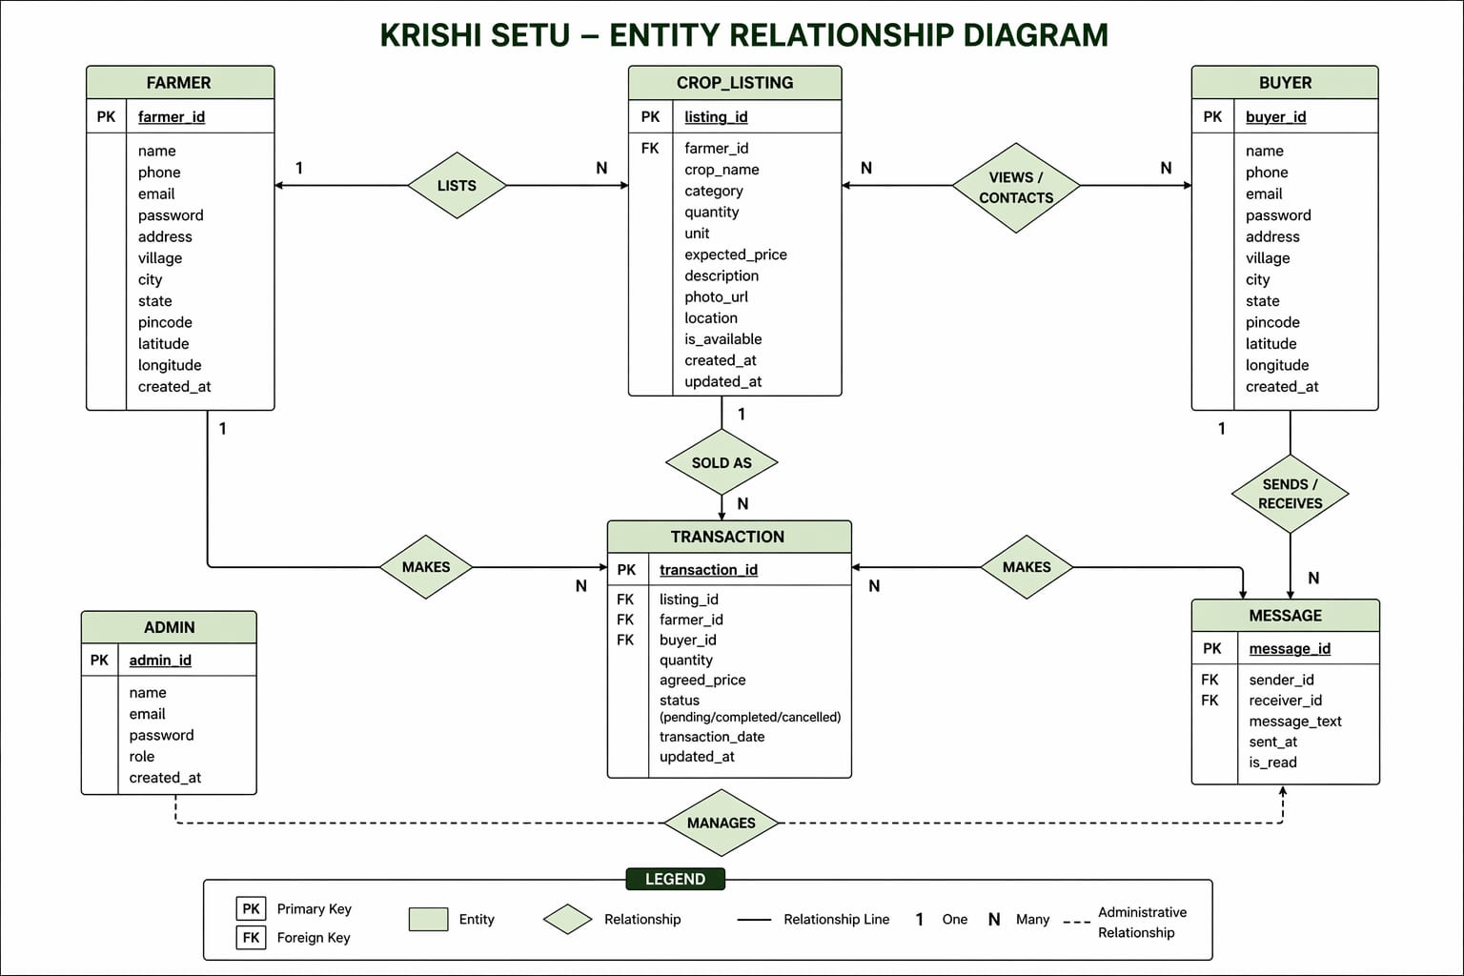

3.2 MODULE SPECIFICATION

The system is divided into multiple modules to ensure efficient functionality and maintainability.

Authentication Module:
This module handles user registration and login functionality. It ensures secure access to the system by validating user credentials and maintaining session data.

Marketplace Module:
This module allows farmers to create, update, and manage crop listings. Buyers can search for crops using filters such as location, price, and category. The module ensures smooth interaction between farmers and buyers.

Communication Module:
The communication module enables real-time chat between farmers and buyers. This allows users to negotiate prices and discuss product details before finalizing transactions.

Location Module:
This module integrates geolocation services to provide location-based filtering. Buyers can search for crops available in nearby areas, improving efficiency and reducing transportation costs.

Analytics Module:
The analytics module processes data to generate price suggestions and crop recommendations. It uses multiple factors such as demand, supply, location, and historical trends to provide insights.

Admin Module:
The admin module allows administrators to monitor system activities, manage users, and handle complaints. It ensures the reliability and security of the platform.

3.3 DATA FLOW DIAGRAM
The Data Flow Diagram (DFD) represents the flow of data within the system. It shows how data moves between users, processes, and the database. The process begins with user registration, where user details are stored in the database. Farmers upload crop information, which is also stored in the system. Buyers retrieve this data through search queries.

Communication between farmers and buyers occurs through the chat module. The system also processes data to generate price suggestions and recommendations.

The DFD helps in understanding the interaction between different components of the system and ensures efficient data management.

3.4 TABLE SPECIFICATION
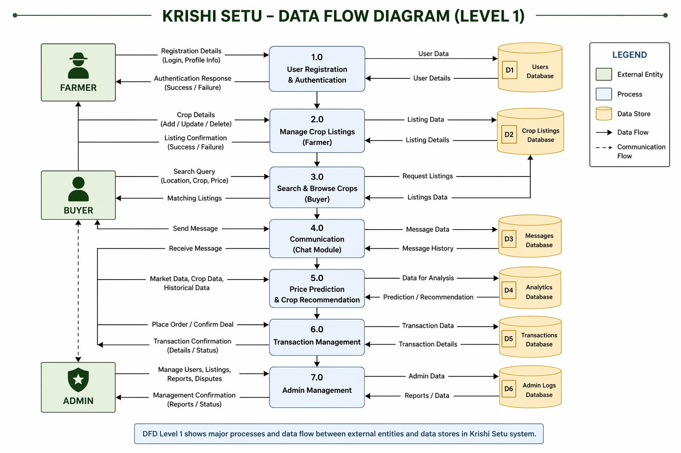
The database is designed to store and manage system data efficiently. The main tables used in the system are as follows:

User Table:
This table stores user information including user ID, name, role (farmer or buyer), contact details, and location.

Crop Listing Table:
This table stores details of crops uploaded by farmers, including crop ID, farmer ID, crop name, quantity, price, and availability.

Transaction Table:
This table records transactions between farmers and buyers. It includes transaction ID, buyer ID, farmer ID, crop ID, and transaction status.

Chat Table:
This table stores messages exchanged between users. It includes message ID, sender ID, receiver ID, message content, and timestamp.

The database structure is designed to ensure data consistency, efficient retrieval, and scalability.

3.5 RESULTS
The implementation of the Krishi Setu system consists of multiple user interfaces designed to support different functionalities for farmers and buyers (off takers). Each interface is developed to ensure usability, efficiency, and real-time interaction within the system.
The following sections describe the major screens of the application along with their functionalities.

LOGIN AND REGISTRATION MODULE
The login and registration interface serves as the entry point to the system. It allows users to securely create accounts and access the platform based on their roles (Farmer or Buyer).
The registration process requires users to provide essential details such as name, contact number, location, and role selection. Authentication is handled securely using backend services, ensuring data protection and controlled access.
The login system validates user credentials and redirects users to their respective dashboards based on their role.
[Paste Screenshot: Login Screen] [Paste Screenshot: Registration Screen]

FARMER MODULE
The farmer module is designed to provide complete control over crop management and interaction with buyers. It includes several features that assist farmers in decision-making and marketplace participation.
Farmer Dashboard:
The farmer dashboard provides an overview of all activities, including active listings, buyer inquiries, and recent interactions. It acts as the central control panel for managing crop-related operations.
[Paste Screenshot: Farmer Dashboard]
Crop Listing Page:
This page allows farmers to upload crop details such as crop name, quantity, expected price, and description. Farmers can also edit or delete existing listings. The system ensures that all listings are stored and updated in real time.
[Paste Screenshot: Add/Edit Crop Listing Page]
Price Suggestion Feature:
The system provides intelligent price suggestions based on factors such as demand, supply, location, and historical trends. This helps farmers set competitive prices and avoid underpricing or overpricing.
[Paste Screenshot: Price Suggestion Display]
Crop Recommendation Feature:
Farmers receive recommendations on which crops to cultivate based on market demand and trends. This feature supports data-driven farming decisions.
[Paste Screenshot: Crop Recommendation Section]
Weather Information Module:
This module provides real-time weather updates based on the farmer’s location. It helps farmers plan agricultural activities such as sowing, irrigation, and harvesting.
[Paste Screenshot: Weather Information Screen]
Location Services:
The system uses GPS-based location services to tag crop listings and enable buyers to find nearby farmers. This improves visibility and reduces transportation challenges.
[Paste Screenshot: Location / Map Tagging Feature]

BUYER (OFFTAKER) MODULE
The buyer module is designed to help users efficiently search for and procure agricultural products. It provides filtering, communication, and decision-support features.
Buyer Dashboard:
The buyer dashboard displays available crop listings, recent searches, and communication history. It provides quick access to all major functionalities.
[Paste Screenshot: Buyer Dashboard]
Search and Filter Page:
Buyers can search for crops based on multiple parameters such as location, crop type, price range, and availability. The filtering system ensures that buyers can quickly find relevant products.
[Paste Screenshot: Search and Filter Interface]
Map-Based Crop Discovery:
The map interface displays crop listings geographically, allowing buyers to identify nearby farmers. This feature enhances accessibility and reduces logistics costs.
[Paste Screenshot: Map-Based Search Screen]
Listing Details Page:
This page provides detailed information about a selected crop, including farmer details, pricing, quantity, and location. Buyers can use this information to make informed purchasing decisions.
[Paste Screenshot: Crop Details Page]

COMMUNICATION MODULE
Chat Interface:
The chat module enables real-time communication between farmers and buyers. It allows users to negotiate prices, clarify details, and finalize transactions.
The system ensures smooth message exchange and maintains chat history for future reference.
[Paste Screenshot: Chat Interface]

TRANSACTION INTERACTION:
If transaction confirmation or order flow is implemented, this section shows how buyers confirm deals and farmers receive confirmation.
[Paste Screenshot: Transaction / Order Confirmation Screen]

Overall, the results demonstrate that the Krishi Setu system successfully integrates multiple functionalities into a unified platform. The application provides a seamless experience for both farmers and buyers, improving communication, decision-making, and market accessibility.

CHAPTER 4

(CONCLUSION)

4.1 SUMMARY OF WORK

The Krishi Setu system has been developed to address the major challenges faced in agricultural markets, particularly the lack of transparency and dependency on intermediaries. The project focuses on creating a digital platform that enables direct interaction between farmers and buyers, thereby improving efficiency and accessibility in agricultural trade.

The system successfully integrates multiple functionalities, including user authentication, crop listing, buyer search, real-time communication, and location-based filtering. These features work together to create a seamless and user-friendly experience for both farmers and buyers.

The inclusion of a price prediction mechanism and crop recommendation feature enhances the decision-making capabilities of farmers. By providing insights based on demand, supply, and historical data, the system encourages data-driven agricultural practices.

The implementation of the system demonstrates that digital platforms can significantly improve market transparency and reduce inefficiencies in traditional agricultural systems. The results indicate that the proposed system has the potential to increase farmer profitability and improve buyer accessibility.

Overall, the project achieves its objectives by providing a scalable and efficient solution for agricultural market challenges.

4.2 FUTURE SCOPE

The Krishi Setu system can be further enhanced by incorporating additional features and technologies to improve its functionality and reach.

One potential improvement is the integration of online payment systems, which would enable secure and seamless transactions between farmers and buyers. This would reduce dependency on cash-based transactions and improve reliability.

The system can also be extended by incorporating machine learning algorithms to improve the accuracy of price prediction and crop recommendation. Advanced models can analyze larger datasets to provide more precise insights.

Another important enhancement is the integration of Internet of Things (IoT) devices for real-time monitoring of agricultural conditions such as soil quality, temperature, and humidity. This would provide farmers with additional data to support decision-making.

The development of an offline mode can improve accessibility in areas with limited internet connectivity. Additionally, multilingual support can be introduced to make the system more user-friendly for diverse user groups.

The platform can also be expanded to include logistics and transportation management, enabling complete end-to-end agricultural supply chain solutions.

4.3 LIMITATIONS

Despite its advantages, the Krishi Setu system has certain limitations that need to be addressed in future development.

The system relies on internet connectivity, which may limit its usability in remote areas with poor network coverage. This can affect real-time communication and data access.

The accuracy of the price prediction model depends on the availability and quality of data. Limited or outdated data may reduce the effectiveness of predictions.

User adoption is another challenge, as farmers may require training and awareness to effectively use the system. Digital literacy plays a crucial role in the successful implementation of such platforms.

Additionally, the system currently focuses on direct interaction and does not include integrated payment or logistics features, which may be necessary for a complete marketplace solution.

Addressing these limitations in future versions of the system will further enhance its effectiveness and usability.

REFERENCES & BIBLIOGRAPHY

[1] Kumar, R.; Singh, S.; “Digital Transformation in Agriculture: Opportunities and Challenges,” International Journal of Agricultural Science, Vol. 12, pp. 145–152 (2021).

[2] Sharma, P.; Verma, A.; “Mobile-Based Agricultural Advisory Systems: A Review,” IEEE Access, Vol. 9, pp. 56789–56802 (2022).

[3] Patel, M.; Desai, A.; “Smart Farming Using IoT and Data Analytics,” Procedia Computer Science, Vol. 165, pp. 204–211 (2020).

[4] Verma, S.; “Market Linkage Models for Farmers in Developing Economies,” Agricultural Systems Journal, Vol. 8, pp. 89–101 (2019).

[5] Reddy, K.; Rao, V.; “Location-Based Services in Mobile Applications,” IEEE Communications Surveys & Tutorials, Vol. 23, pp. 1021–1045 (2021).

[6] Firebase Documentation; “Cloud Fire store and Realtime Database,” Google Firebase, Available: https://firebase.google.com/docs (Accessed: 2026).

[7] Google Developers; “Google Maps Platform API Documentation,” Available: https://developers.google.com/maps (Accessed: 2026).
APPENDICES

APPENDIX I
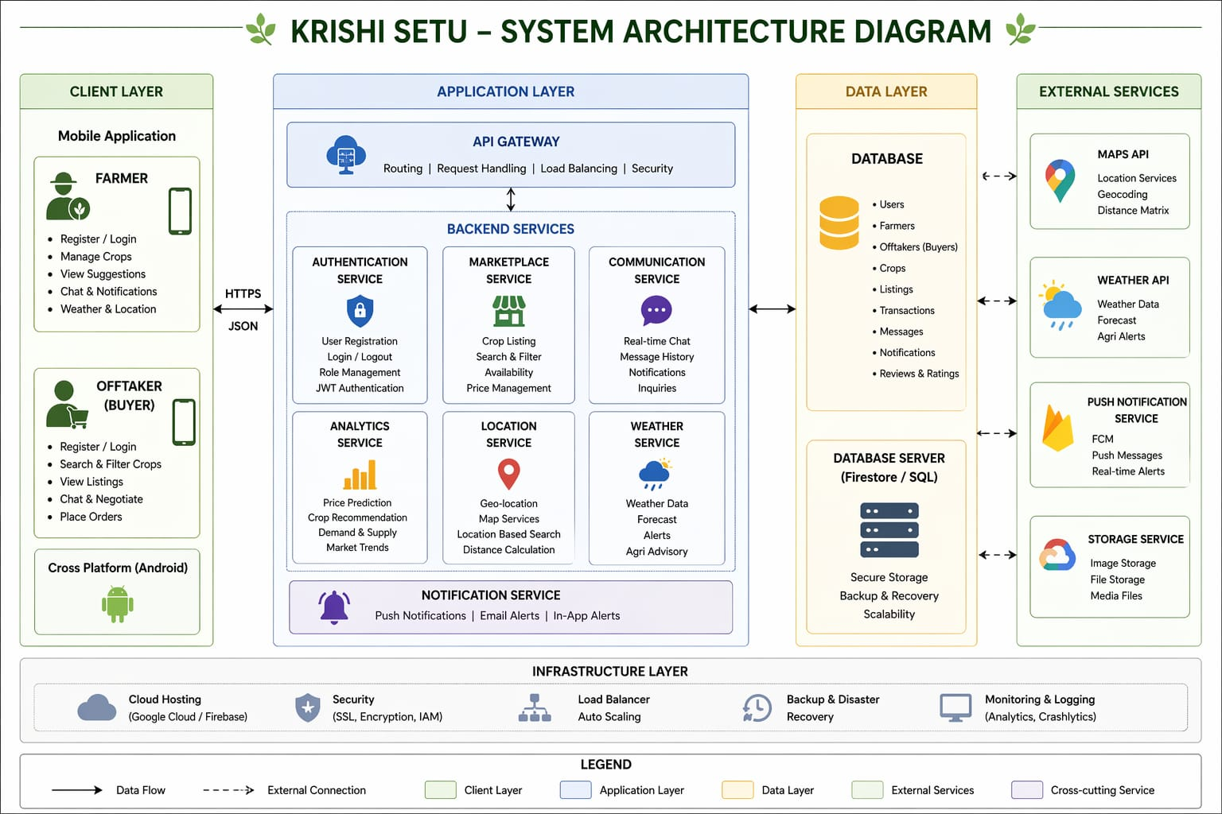
SYSTEM ARCHITECTURE DIAGRAM

This appendix presents the overall architecture of the Krishi Setu system. The architecture follows a client–server model where the mobile application interacts with backend services for data processing and storage. The system includes modules such as authentication, marketplace, communication, analytics, and location services.

APPENDIX II
DATA FLOW DIAGRAM

This appendix illustrates the flow of data within the system. It shows how data is transferred between users, processes, and the database. The diagram highlights key processes such as user authentication, crop listing, search, and communication.

[Insert Data Flow Diagram here]

APPENDIX III
ENTITY RELATIONSHIP DIAGRAM

This appendix shows the database structure of the system, including entities such as Farmer, Buyer, Crop Listing, Transaction, and Admin. The relationships between these entities ensure proper data management.

[Insert ER Diagram here]

APPENDIX IV
APPLICATION SCREENSHOTS

This appendix includes screenshots of the developed application to demonstrate system functionality.

Figure A1: Login Screen
Figure A2: Registration Screen
Figure A3: Farmer Dashboard
Figure A4: Buyer Dashboard
Figure A5: Crop Listing Page
Figure A6: Chat Interface
Figure A7: Map-Based Search

APPENDIX V
PROJECT DOCUMENTS AND CERTIFICATES

This appendix contains supporting documents related to the project, including research paper submission proof, copyright status, and other relevant certificates.

[Insert Certificates / Proof Documents here]

PROJECT TEAM MEMBERS INFORMATION
Name: Himanshu Shejre
UID: 25105002
Branch: Computer Science and Business Systems
Year: Second Year (IV Semester)
College: St. Vincent Pallotti College of Engineering and Technology, Nagpur

Name: Sudeep Kuralkar
UID: 24005012
Branch: Computer Science and Business Systems
Year: Second Year (IV Semester)
College: St. Vincent Pallotti College of Engineering and Technology, Nagpur

